Proiect SGBD

## Alexandru-Daniel Tiganus

# Utilitatea bazei de date

Modelul descrie o companie care produce si comercializeaza parfumuri. Compania se ocupa atat de fabricarea cat si de depozitarea si de vanzarea acestora. Clientii plaseaza comenzi si pot lua parfumuri facute de companie. Nu exista intermediari, deci costul parfumurilor e redus.

# Diagrama entitate-relatie

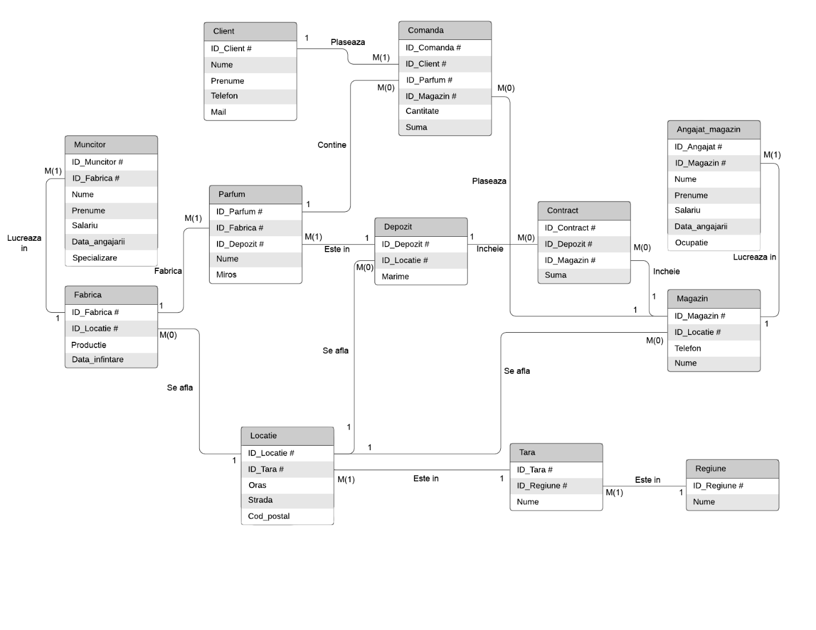

# Diagrama conceptuala

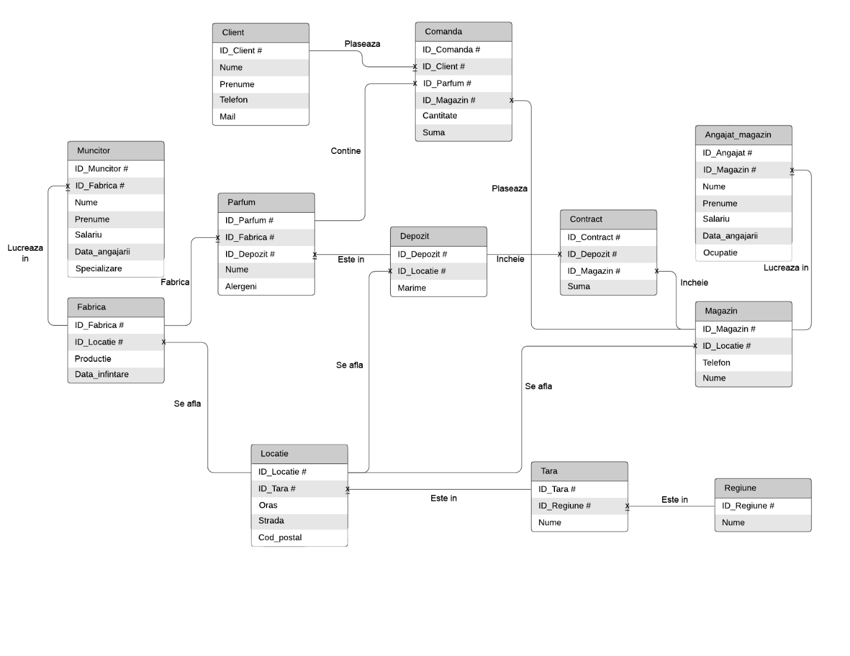

# Implementare model

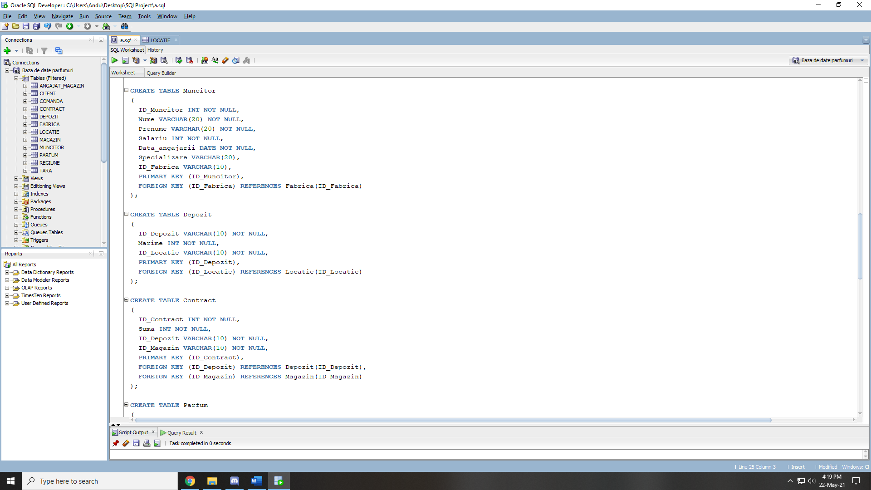

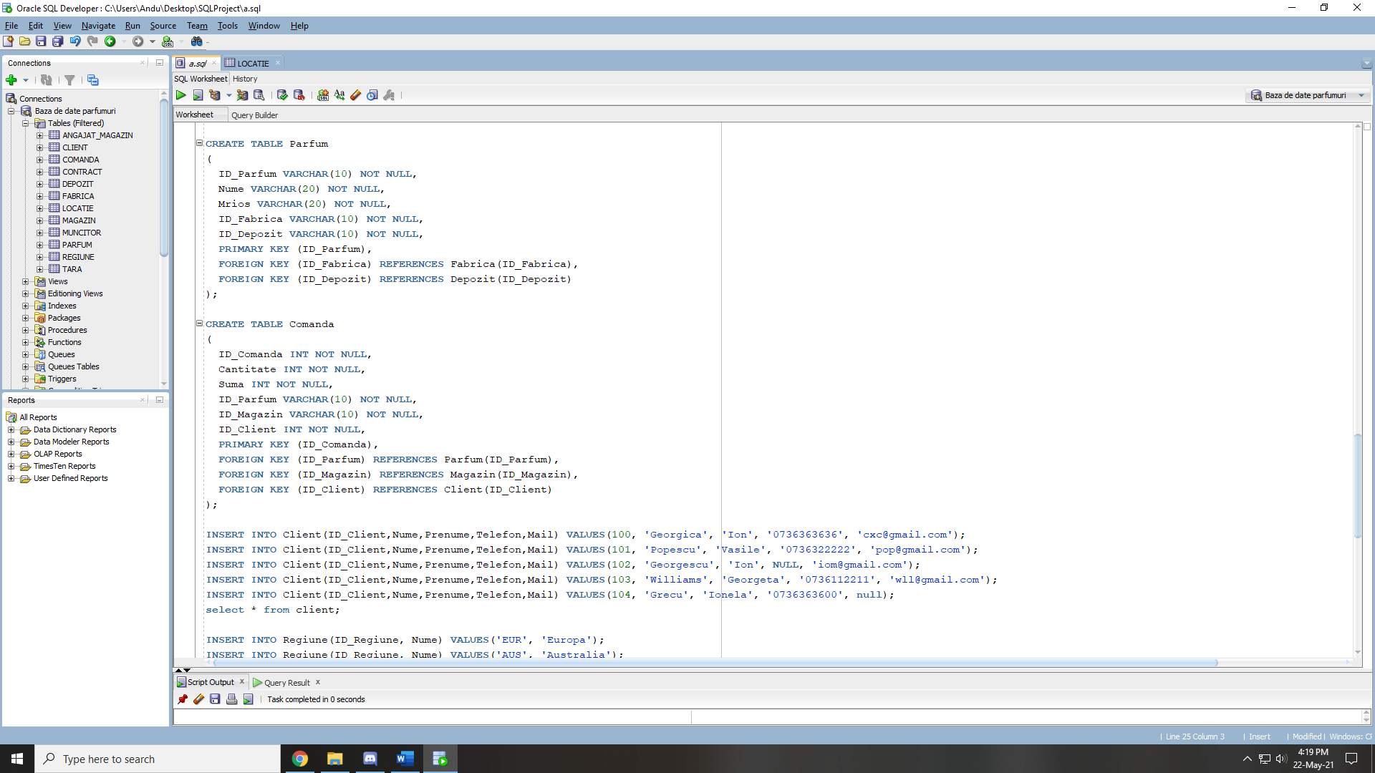

CREATE TABLE Client

(

ID_Client INT NOT NULL,

Nume VARCHAR(20) NOT NULL,

Prenume VARCHAR(20),

Telefon VARCHAR(20),

Mail VARCHAR(20),

PRIMARY KEY (ID_Client)

);

CREATE TABLE Regiune

(

ID_Regiune VARCHAR(20) NOT NULL,

Nume VARCHAR(20) NOT NULL,

PRIMARY KEY (ID_Regiune)

);

CREATE TABLE Tara

(

ID_Tara VARCHAR(10) NOT NULL,

Nume VARCHAR(20) NOT NULL,

ID_Regiune VARCHAR(20) NOT NULL,

PRIMARY KEY (ID_Tara),

FOREIGN KEY (ID_Regiune) REFERENCES Regiune(ID_Regiune)

);

CREATE TABLE Locatie

(

ID_Locatie VARCHAR(10) NOT NULL,

Cod_postal VARCHAR(10) NOT NULL,

Strada VARCHAR(30),

ID_Tara VARCHAR(10),

Oras VARCHAR(20) NOT NULL,

PRIMARY KEY (ID_Locatie),

FOREIGN KEY (ID_Tara) REFERENCES Tara(ID_Tara)

);

CREATE TABLE Magazin

(

ID_Magazin VARCHAR(10) NOT NULL,

Telefon VARCHAR(20),

Nume VARCHAR(20) NOT NULL,

ID_Locatie VARCHAR(10) NOT NULL,

PRIMARY KEY (ID_Magazin),

FOREIGN KEY (ID_Locatie) REFERENCES Locatie(ID_Locatie)

);

CREATE TABLE Angajat_magazin

(

ID_Angajat INT NOT NULL,

Nume VARCHAR(20) NOT NULL,

Prenume VARCHAR(20) NOT NULL,

Salariu INT NOT NULL,

Data_angajarii DATE NOT NULL,

Ocupatie VARCHAR(20),

ID_Magazin VARCHAR(10) NOT NULL,

PRIMARY KEY (ID_Angajat),

FOREIGN KEY (ID_Magazin) REFERENCES Magazin(ID_Magazin)

);

CREATE TABLE Fabrica

(

ID_Fabrica VARCHAR(10) NOT NULL,

Productie INT NOT NULL,

Data_infintare DATE NOT NULL,

ID_Locatie VARCHAR(10) NOT NULL,

PRIMARY KEY (ID_Fabrica),

FOREIGN KEY (ID_Locatie) REFERENCES Locatie(ID_Locatie)

);

CREATE TABLE Muncitor

(

ID_Muncitor INT NOT NULL,

Nume VARCHAR(20) NOT NULL,

Prenume VARCHAR(20) NOT NULL,

Salariu INT NOT NULL,

Data_angajarii DATE NOT NULL,

Specializare VARCHAR(20),

ID_Fabrica VARCHAR(10),

PRIMARY KEY (ID_Muncitor),

FOREIGN KEY (ID_Fabrica) REFERENCES Fabrica(ID_Fabrica)

);

CREATE TABLE Depozit

(

ID_Depozit VARCHAR(10) NOT NULL,

Marime INT NOT NULL,

ID_Locatie VARCHAR(10) NOT NULL,

PRIMARY KEY (ID_Depozit),

FOREIGN KEY (ID_Locatie) REFERENCES Locatie(ID_Locatie)

);

CREATE TABLE Contract

(

ID_Contract INT NOT NULL,

Suma INT NOT NULL,

ID_Depozit VARCHAR(10) NOT NULL,

ID_Magazin VARCHAR(10) NOT NULL,

PRIMARY KEY (ID_Contract),

FOREIGN KEY (ID_Depozit) REFERENCES Depozit(ID_Depozit),

FOREIGN KEY (ID_Magazin) REFERENCES Magazin(ID_Magazin)

);

CREATE TABLE Parfum

(

ID_Parfum VARCHAR(10) NOT NULL,

Nume VARCHAR(20) NOT NULL,

Miros VARCHAR(20) NOT NULL,

ID_Fabrica VARCHAR(10) NOT NULL,

ID_Depozit VARCHAR(10) NOT NULL,

PRIMARY KEY (ID_Parfum),

FOREIGN KEY (ID_Fabrica) REFERENCES Fabrica(ID_Fabrica),

FOREIGN KEY (ID_Depozit) REFERENCES Depozit(ID_Depozit)

);

CREATE TABLE Comanda

(

ID_Comanda INT NOT NULL,

Cantitate INT NOT NULL,

Suma INT NOT NULL,

ID_Parfum VARCHAR(10) NOT NULL,

ID_Magazin VARCHAR(10) NOT NULL,

ID_Client INT NOT NULL,

PRIMARY KEY (ID_Comanda),

FOREIGN KEY (ID_Parfum) REFERENCES Parfum(ID_Parfum),

FOREIGN KEY (ID_Magazin) REFERENCES Magazin(ID_Magazin),

FOREIGN KEY (ID_Client) REFERENCES Client(ID_Client)

);

# Adaugare informatii

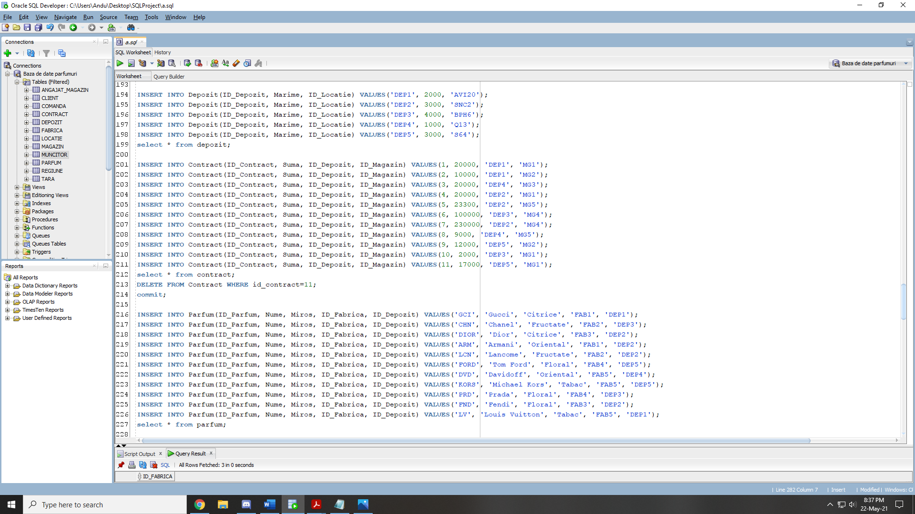

INSERT INTO Client(ID_Client,Nume,Prenume,Telefon,Mail) VALUES(100, 'Georgica', 'Ion', '0736363636', 'cxc@gmail.com');

INSERT INTO Client(ID_Client,Nume,Prenume,Telefon,Mail) VALUES(101, 'Popescu', 'Vasile', '0736322222', 'pop@gmail.com');

INSERT INTO Client(ID_Client,Nume,Prenume,Telefon,Mail) VALUES(102, 'Georgescu', 'Ion', NULL, 'iom@gmail.com');

INSERT INTO Client(ID_Client,Nume,Prenume,Telefon,Mail) VALUES(103, 'Williams', 'Georgeta', '0736112211', 'wll@gmail.com');

INSERT INTO Client(ID_Client,Nume,Prenume,Telefon,Mail) VALUES(104, 'Grecu', 'Ionela', '0736363600', null);

select * from client;

INSERT INTO Regiune(ID_Regiune, Nume) VALUES('EUR', 'Europa');

INSERT INTO Regiune(ID_Regiune, Nume) VALUES('AUS', 'Australia');

INSERT INTO Regiune(ID_Regiune, Nume) VALUES('ASI', 'Asia');

INSERT INTO Regiune(ID_Regiune, Nume) VALUES('ANO', 'America de Nord');

INSERT INTO Regiune(ID_Regiune, Nume) VALUES('ASU', 'America de Sud');

select * from regiune;

INSERT INTO Tara(ID_Tara, Nume, ID_Regiune) VALUES('RO', 'Romania', 'EUR');

INSERT INTO Tara(ID_Tara, Nume, ID_Regiune) VALUES('DE', 'Germania', 'EUR');

INSERT INTO Tara(ID_Tara, Nume, ID_Regiune) VALUES('US', 'Statele Unite', 'ANO');

INSERT INTO Tara(ID_Tara, Nume, ID_Regiune) VALUES('CH', 'China', 'ASI');

INSERT INTO Tara(ID_Tara, Nume, ID_Regiune) VALUES('BZ', 'Brazilia', 'ASU');

select* from tara;

INSERT INTO Locatie(ID_Locatie, Cod_postal, Strada, ID_Tara, Oras) VALUES('SHN1', '002233', 'Serban Huinu 1', 'RO', 'Bucuresti');

INSERT INTO Locatie(ID_Locatie, Cod_postal, Strada, ID_Tara, Oras) VALUES('RCC34', '056493', 'Rech Cron 34', 'DE', 'Hamburg');

INSERT INTO Locatie(ID_Locatie, Cod_postal, Strada, ID_Tara, Oras) VALUES('Q13', '53221', 'Qianmen 13', 'CH', 'Beijing');

INSERT INTO Locatie(ID_Locatie, Cod_postal, Strada, ID_Tara, Oras) VALUES('S64', '430222', 'Sloath 41', 'US', 'San Francisco');

INSERT INTO Locatie(ID_Locatie, Cod_postal, Strada, ID_Tara, Oras) VALUES('BPH6', null, 'Bogdan P. Hasdeu 6', 'RO', 'Craiova');

INSERT INTO Locatie(ID_Locatie, Cod_postal, Strada, ID_Tara, Oras) VALUES('BZE3', '212333', 'Bezeor 3', 'BZ', 'Brasilia');

INSERT INTO Locatie(ID_Locatie, Cod_postal, Strada, ID_Tara, Oras) VALUES('SNC2', '346783', 'Sincai 15', 'RO', 'Bucuresti');

INSERT INTO Locatie(ID_Locatie, Cod_postal, Strada, ID_Tara, Oras) VALUES('AVI20', '388543', 'Aviatorilor 20', 'RO', 'Iasi');

select * from locatie;

INSERT INTO Magazin(ID_Magazin, Telefon, Nume, ID_Locatie ) VALUES('MG1', '+8616742264298', 'Beijing parfumes', 'Q13');

INSERT INTO Magazin(ID_Magazin, Telefon, Nume, ID_Locatie ) VALUES('MG2', '+40736073135', 'Luxury shop', 'SHN1');

INSERT INTO Magazin(ID_Magazin, Telefon, Nume, ID_Locatie ) VALUES('MG3', '+491515553057', 'German quality', 'RCC34');

INSERT INTO Magazin(ID_Magazin, Telefon, Nume, ID_Locatie ) VALUES('MG4', '+14842634732', 'San parfume', 'S64');

INSERT INTO Magazin(ID_Magazin, Telefon, Nume, ID_Locatie ) VALUES('MG5', '+40722222222', 'Parfumuri de top', 'BPH6');

select * from magazin;

INSERT INTO Angajat_magazin(ID_Angajat, Nume, Prenume, Salariu, Data_angajarii, Ocupatie, ID_Magazin) VALUES(1000, 'Ion', 'Croco', 2000, TO_DATE('17/12/2015', 'DD/MM/YYYY'), 'Vanzator', 'MG1');

INSERT INTO Angajat_magazin(ID_Angajat, Nume, Prenume, Salariu, Data_angajarii, Ocupatie, ID_Magazin) VALUES(1001, 'Vasile', 'Popescu', 2000, TO_DATE('12/10/2012', 'DD/MM/YYYY'), 'Vanzator', 'MG2');

INSERT INTO Angajat_magazin(ID_Angajat, Nume, Prenume, Salariu, Data_angajarii, Ocupatie, ID_Magazin) VALUES(1002, 'Vasile', 'Campineanu', 4000, TO_DATE('24/03/2001', 'DD/MM/YYYY'), 'Manager', 'MG3');

INSERT INTO Angajat_magazin(ID_Angajat, Nume, Prenume, Salariu, Data_angajarii, Ocupatie, ID_Magazin) VALUES(1003, 'Herbert', 'Bobbins', 2500, TO_DATE('11/11/2011', 'DD/MM/YYYY'), 'Vanzator', 'MG4');

INSERT INTO Angajat_magazin(ID_Angajat, Nume, Prenume, Salariu, Data_angajarii, Ocupatie, ID_Magazin) VALUES(1004, 'George', 'Ionel', 1000, TO_DATE('10/12/2012', 'DD/MM/YYYY'), 'Ingrijitor', 'MG5');

select * from angajat_magazin;

INSERT INTO Fabrica(ID_Fabrica, Data_infintare, Productie, ID_Locatie) VALUES('FAB1', TO_DATE('10/12/2001', 'DD/MM/YYYY'), 2000, 'AVI20');

INSERT INTO Fabrica(ID_Fabrica, Data_infintare, Productie, ID_Locatie) VALUES('FAB2', TO_DATE('01/02/1990', 'DD/MM/YYYY'), 1200, 'BZE3');

INSERT INTO Fabrica(ID_Fabrica, Data_infintare, Productie, ID_Locatie) VALUES('FAB3', TO_DATE('05/06/1984', 'DD/MM/YYYY'), 1000, 'SNC2');

INSERT INTO Fabrica(ID_Fabrica, Data_infintare, Productie, ID_Locatie) VALUES('FAB4', TO_DATE('12/12/2016', 'DD/MM/YYYY'), 4000, 'Q13');

INSERT INTO Fabrica(ID_Fabrica, Data_infintare, Productie, ID_Locatie) VALUES('FAB5', TO_DATE('07/09/2012', 'DD/MM/YYYY'), 3200, 'S64');

select * from fabrica;

INSERT INTO Muncitor(ID_Muncitor, Nume, Prenume, Salariu, Data_angajarii, Specializare, ID_Fabrica) VALUES(2000, 'Alexandru', 'Vasilaru', 800, TO_DATE('17/12/2015', 'DD/MM/YYYY'), 'Sticlar', 'FAB1');

INSERT INTO Muncitor(ID_Muncitor, Nume, Prenume, Salariu, Data_angajarii, Specializare, ID_Fabrica) VALUES(2001, 'Bob', 'Stocks', 900, TO_DATE('10/06/2012', 'DD/MM/YYYY'), 'Sticlar', 'FAB2');

INSERT INTO Muncitor(ID_Muncitor, Nume, Prenume, Salariu, Data_angajarii, Specializare, ID_Fabrica) VALUES(2002, 'Shi', 'San Ping', 1700, TO_DATE('17/12/2018', 'DD/MM/YYYY'), 'Parfumier', 'FAB3');

INSERT INTO Muncitor(ID_Muncitor, Nume, Prenume, Salariu, Data_angajarii, Specializare, ID_Fabrica) VALUES(2003, 'Matei', 'Olteanu', 1700, TO_DATE('24/03/2014', 'DD/MM/YYYY'), 'Parfumier', 'FAB4');

INSERT INTO Muncitor(ID_Muncitor, Nume, Prenume, Salariu, Data_angajarii, Specializare, ID_Fabrica) VALUES(2004, 'Florin', 'Filimon', 1500, TO_DATE('30/10/2019', 'DD/MM/YYYY'), 'Parfumier', 'FAB5');

INSERT INTO Muncitor(ID_Muncitor, Nume, Prenume, Salariu, Data_angajarii, Specializare, ID_Fabrica) VALUES(2005, 'Adrian', 'Florinache', 3300, TO_DATE('05/12/1999', 'DD/MM/YYYY'), 'Maistru', 'FAB1');

INSERT INTO Muncitor(ID_Muncitor, Nume, Prenume, Salariu, Data_angajarii, Specializare, ID_Fabrica) VALUES(2006, 'George', 'Cal', 3300, TO_DATE('05/10/2006', 'DD/MM/YYYY'), 'Maistru', 'FAB1');

INSERT INTO Muncitor(ID_Muncitor, Nume, Prenume, Salariu, Data_angajarii, Specializare, ID_Fabrica) VALUES(2007, 'Alin', 'Zlotea', 1000, TO_DATE('28/12/2009', 'DD/MM/YYYY'), 'Sticlar', 'FAB2');

INSERT INTO Muncitor(ID_Muncitor, Nume, Prenume, Salariu, Data_angajarii, Specializare, ID_Fabrica) VALUES(2008, 'Alexandru', 'Marcu', 1600, TO_DATE('25/04/2009', 'DD/MM/YYYY'), 'Parfumier', 'FAB3');

INSERT INTO Muncitor(ID_Muncitor, Nume, Prenume, Salariu, Data_angajarii, Specializare, ID_Fabrica) VALUES(2009, 'Alexandru', 'Ionel', 1000, TO_DATE('23/05/2020', 'DD/MM/YYYY'), 'Parfumier', null);

INSERT INTO Muncitor(ID_Muncitor, Nume, Prenume, Salariu, Data_angajarii, Specializare, ID_Fabrica) VALUES(2010, 'Grigore', 'Alexandrescu', 1000, TO_DATE('03/02/2000', 'DD/MM/YYYY'), 'Parfumier', 'FAB4');

select * from muncitor;

INSERT INTO Depozit(ID_Depozit, Marime, ID_Locatie) VALUES('DEP1', 2000, 'AVI20');

INSERT INTO Depozit(ID_Depozit, Marime, ID_Locatie) VALUES('DEP2', 3000, 'SNC2');

INSERT INTO Depozit(ID_Depozit, Marime, ID_Locatie) VALUES('DEP3', 4000, 'BPH6');

INSERT INTO Depozit(ID_Depozit, Marime, ID_Locatie) VALUES('DEP4', 1000, 'Q13');

INSERT INTO Depozit(ID_Depozit, Marime, ID_Locatie) VALUES('DEP5', 3000, 'S64');

select * from depozit;

INSERT INTO Contract(ID_Contract, Suma, ID_Depozit, ID_Magazin) VALUES(1, 20000, 'DEP1', 'MG1');

INSERT INTO Contract(ID_Contract, Suma, ID_Depozit, ID_Magazin) VALUES(2, 10000, 'DEP1', 'MG2');

INSERT INTO Contract(ID_Contract, Suma, ID_Depozit, ID_Magazin) VALUES(3, 20000, 'DEP4', 'MG3');

INSERT INTO Contract(ID_Contract, Suma, ID_Depozit, ID_Magazin) VALUES(4, 20000, 'DEP2', 'MG1');

INSERT INTO Contract(ID_Contract, Suma, ID_Depozit, ID_Magazin) VALUES(5, 23300, 'DEP2', 'MG5');

INSERT INTO Contract(ID_Contract, Suma, ID_Depozit, ID_Magazin) VALUES(6, 100000, 'DEP3', 'MG4');

INSERT INTO Contract(ID_Contract, Suma, ID_Depozit, ID_Magazin) VALUES(7, 230000, 'DEP2', 'MG4');

INSERT INTO Contract(ID_Contract, Suma, ID_Depozit, ID_Magazin) VALUES(8, 9000, 'DEP4', 'MG5');

INSERT INTO Contract(ID_Contract, Suma, ID_Depozit, ID_Magazin) VALUES(9, 12000, 'DEP5', 'MG2');

INSERT INTO Contract(ID_Contract, Suma, ID_Depozit, ID_Magazin) VALUES(10, 2000, 'DEP3', 'MG1');

INSERT INTO Contract(ID_Contract, Suma, ID_Depozit, ID_Magazin) VALUES(11, 17000, 'DEP5', 'MG1');

select * from contract;

DELETE FROM Contract WHERE id_contract=11;

commit;

INSERT INTO Parfum(ID_Parfum, Nume, Miros, ID_Fabrica, ID_Depozit) VALUES('GCI', 'Gucci', 'Citrice', 'FAB1', 'DEP1');

INSERT INTO Parfum(ID_Parfum, Nume, Miros, ID_Fabrica, ID_Depozit) VALUES('CHN', 'Chanel', 'Fructate', 'FAB2', 'DEP3');

INSERT INTO Parfum(ID_Parfum, Nume, Miros, ID_Fabrica, ID_Depozit) VALUES('DIOR', 'Dior', 'Citrice', 'FAB3', 'DEP2');

INSERT INTO Parfum(ID_Parfum, Nume, Miros, ID_Fabrica, ID_Depozit) VALUES('ARM', 'Armani', 'Oriental', 'FAB1', 'DEP2');

INSERT INTO Parfum(ID_Parfum, Nume, Miros, ID_Fabrica, ID_Depozit) VALUES('LCN', 'Lancome', 'Fructate', 'FAB2', 'DEP2');

INSERT INTO Parfum(ID_Parfum, Nume, Miros, ID_Fabrica, ID_Depozit) VALUES('FORD', 'Tom Ford', 'Floral', 'FAB4', 'DEP5');

INSERT INTO Parfum(ID_Parfum, Nume, Miros, ID_Fabrica, ID_Depozit) VALUES('DVD', 'Davidoff', 'Oriental', 'FAB5', 'DEP4');

INSERT INTO Parfum(ID_Parfum, Nume, Miros, ID_Fabrica, ID_Depozit) VALUES('KORS', 'Michael Kors', 'Tabac', 'FAB5', 'DEP5');

INSERT INTO Parfum(ID_Parfum, Nume, Miros, ID_Fabrica, ID_Depozit) VALUES('PRD', 'Prada', 'Floral', 'FAB4', 'DEP3');

INSERT INTO Parfum(ID_Parfum, Nume, Miros, ID_Fabrica, ID_Depozit) VALUES('FND', 'Fendi', 'Floral', 'FAB3', 'DEP2');

INSERT INTO Parfum(ID_Parfum, Nume, Miros, ID_Fabrica, ID_Depozit) VALUES('LV', 'Louis Vuitton', 'Tabac', 'FAB5', 'DEP1');

select * from parfum;

INSERT INTO Comanda(ID_Comanda, Cantitate, Suma, ID_Parfum, ID_Magazin, ID_Client) VALUES(1, 2, 200, 'FORD', 'MG4', 100);

INSERT INTO Comanda(ID_Comanda, Cantitate, Suma, ID_Parfum, ID_Magazin, ID_Client) VALUES(2, 4, 440, 'FND', 'MG5', 101);

INSERT INTO Comanda(ID_Comanda, Cantitate, Suma, ID_Parfum, ID_Magazin, ID_Client) VALUES(3, 5, 500, 'FORD', 'MG4', 102);

INSERT INTO Comanda(ID_Comanda, Cantitate, Suma, ID_Parfum, ID_Magazin, ID_Client) VALUES(4, 1, 200, 'GCI', 'MG1', 102);

INSERT INTO Comanda(ID_Comanda, Cantitate, Suma, ID_Parfum, ID_Magazin, ID_Client) VALUES(5, 2, 240, 'KORS', 'MG2', 100);

INSERT INTO Comanda(ID_Comanda, Cantitate, Suma, ID_Parfum, ID_Magazin, ID_Client) VALUES(6, 3, 800, 'DIOR', 'MG5', 101);

INSERT INTO Comanda(ID_Comanda, Cantitate, Suma, ID_Parfum, ID_Magazin, ID_Client) VALUES(7, 1, 140, 'LCN', 'MG5', 100);

INSERT INTO Comanda(ID_Comanda, Cantitate, Suma, ID_Parfum, ID_Magazin, ID_Client) VALUES(8, 6, 1400, 'ARM', 'MG5', 104);

INSERT INTO Comanda(ID_Comanda, Cantitate, Suma, ID_Parfum, ID_Magazin, ID_Client) VALUES(9, 24, 2000, 'DVD', 'MG3', 104);

INSERT INTO Comanda(ID_Comanda, Cantitate, Suma, ID_Parfum, ID_Magazin, ID_Client) VALUES(10, 5, 500, 'FND', 'MG4', 102);

INSERT INTO Comanda(ID_Comanda, Cantitate, Suma, ID_Parfum, ID_Magazin, ID_Client) VALUES(11, 2, 200, 'FND', 'MG4', 103);

select * from comanda;

# Problema

-- Creati o functie care gaseste numarul angajatilor care au fost angajati printre primii n oameni la firma, si lucreaza intr-una din cele mai noi deschise m fabrici.

CREATE OR REPLACE FUNCTION Numar_muncitori_adt(n in number, m in number) return number is rezultat number(10);

TYPE tablou_muncitori IS TABLE OF muncitor%ROWTYPE INDEX BY BINARY_INTEGER;

TYPE vector_fabrici IS VARRAY(100) OF fabrica%ROWTYPE;

muncitori tablou_muncitori;

fabrici vector_fabrici;

i binary_integer;

j binary_integer;

BEGIN

select *

bulk collect into muncitori

from( select * from muncitor order by data_angajarii )

where rownum <= n;

select *

bulk collect into fabrici

from( select * from fabrica order by data_infintare desc )

where rownum <= m;

i := muncitori.first;

rezultat := 0;

while (i is not null) loop

j := fabrici.first;

while (j is not null) loop

if muncitori(i).id_fabrica = fabrici(j).id_fabrica then

rezultat := rezultat + 1;

end if;

j := fabrici.next(j);

end loop;

i := muncitori.next(i);

end loop;

return rezultat;

END Numar_muncitori_adt;

/

DECLARE

BEGIN

DBMS_OUTPUT.PUT_LINE('Numarul de angajati este '|| Numar_muncitori_adt(5, 2));

DBMS_OUTPUT.PUT_LINE('Numarul de angajati este '|| Numar_muncitori_adt(5, 3));

END;

# Problema

-- Afisati pentru fiecare magazin toti angajatii care lucreaza la el.

CREATE OR REPLACE PROCEDURE Angajati_magazin_adt is

CURSOR magazine IS SELECT id_magazin, nume FROM magazin;

CURSOR angajati IS SELECT id_magazin, nume, prenume FROM angajat_magazin;

id_m magazin.id_magazin%type;

nume_m magazin.nume%type;

id_a angajat_magazin.id_magazin%type;

nume_a angajat_magazin.nume%type;

prenume_a angajat_magazin.prenume%type;

BEGIN

OPEN magazine;

LOOP

FETCH magazine INTO id_m, nume_m;

EXIT WHEN magazine%NOTFOUND;

DBMS_OUTPUT.PUT_LINE ('Nume magazin: '|| nume_m);

OPEN angajati;

LOOP

FETCH angajati INTO id_a, nume_a, prenume_a;

EXIT WHEN angajati%NOTFOUND;

IF id_m = id_a THEN

DBMS_OUTPUT.PUT_LINE(nume_a || ' ' || prenume_a);

END IF;

END LOOP;

DBMS_OUTPUT.PUT_LINE('');

CLOSE angajati;

END LOOP;

CLOSE magazine;

END Angajati_magazin_adt;

/

DECLARE

BEGIN

Angajati_magazin_adt;

END;

/

# Problema

-- Afisati numarul de muncitori care au lucrat la fabricarea unui parfum dat ca parametru.

CREATE OR REPLACE FUNCTION Muncitori_parfumuri_adt(nume_parfum in parfum.nume%type) return number is rezultat number(10);

nume_invalid exception;

nume_check number;

BEGIN

select count(*)

into nume_check

from parfum

where nume_parfum = parfum.nume;

if nume_check = 0 then

raise nume_invalid;

end if;

select count(*)

into rezultat

from parfum p

join fabrica f on p.id_fabrica = f.id_fabrica

join muncitor m on f.id_fabrica = m.id_fabrica

where lower(p.nume) = lower(nume_parfum);

return rezultat;

EXCEPTION -- nu prea pot aparea exceptii pentru ca countul mereu va pune ceva in variabile, si daca nu se gaseste nimic in tabele, countul va fi 0, ceea ce e ok

when nume_invalid then

DBMS_OUTPUT.PUT_LINE('Nu exista parfumuri cu numele dat.');

when others then

DBMS_OUTPUT.PUT_LINE('Alta eroare: ' || SQLCODE || ' - ' || SQLERRM);

END Muncitori_parfumuri_adt;

/

DECLARE

BEGIN

-- alte exceptii nu pot fi obtinute

DBMS_OUTPUT.PUT_LINE('Numarul de muncitori este '|| Muncitori_parfumuri_adt('Gucci'));

DBMS_OUTPUT.PUT_LINE('Numarul de muncitori este '|| Muncitori_parfumuri_adt('Guscci'));

END;

/

# Problema

-- Dandu-se id-ul unei comenzi si numele unui parfum aflati din ce tara provine parfumul comandat (din ce tara este magazinul de unde a fost comandat).

CREATE OR REPLACE PROCEDURE Tara_parfum_adt(nume_parfum in parfum.nume%type, idul_comenzii in comanda.id_comanda%type) is

nume_tara tara.nume%type;

BEGIN

select t.nume

into nume_tara

from tara t

join locatie l on t.id_tara = l.id_tara

join magazin m on m.id_locatie = l.id_locatie

join comanda c on c.id_magazin = m.id_magazin

join parfum p on p.id_parfum = c.id_parfum

where lower(p.nume) = lower(nume_parfum) and c.id_comanda = idul_comenzii;

DBMS_OUTPUT.PUT_LINE('Tara este ' || nume_tara);

EXCEPTION

when NO_DATA_FOUND then

DBMS_OUTPUT.PUT_LINE('Nu exista parfumul pe comanda data sau nu exista comanda: ' || SQLCODE || ' - ' || SQLERRM);

when TOO_MANY_ROWS then

DBMS_OUTPUT.PUT_LINE('Parfumul are mai multe tari de provenienta: ' || SQLCODE || ' - ' || SQLERRM);

when others then

DBMS_OUTPUT.PUT_LINE('Alta eroare: ' || SQLCODE || ' - ' || SQLERRM);

END Tara_parfum_adt;

/

DECLARE

BEGIN

-- cred ca doar NO_DATA_FOUND poate fi obtinuta cu ce am facut mai sus

Tara_parfum_adt('Armani', 8);

Tara_parfum_adt('Armani', 7);

Tara_parfum_adt('Armani', 37);

END;

/

# Trigger

-- Creati un trigger care sa permita modificarea tabelului muncitor doar in prima zi a lunii, caci numai atunci se vrea sa se faca angajari/concedieri/schimbari salariale.

CREATE OR REPLACE TRIGGER salariu_check_adt

BEFORE INSERT OR UPDATE OR DELETE ON muncitor

BEGIN

IF (TO_CHAR(SYSDATE,'DD') != '01') THEN

RAISE_APPLICATION_ERROR(-20001, 'Tabelul muncitor poate fi modificat doar in prima zi a lunii!');

END IF;

END;

/

DROP TRIGGER salariu_check_adt;

-- verificare

INSERT INTO Muncitor(ID_Muncitor, Nume, Prenume, Salariu, Data_angajarii, Specializare, ID_Fabrica) VALUES(3000, 'Alexandru', 'Vasilaru', 800, TO_DATE('17/12/2015', 'DD/MM/YYYY'), 'Sticlar', 'FAB1');

# Trigger

-- Creati un trigger care nu permite micsorarea sumei unei comenzi odata ce a fost plasata.

CREATE OR REPLACE TRIGGER comanda_check_adt

BEFORE UPDATE OF suma ON comanda FOR EACH ROW

BEGIN

IF (:OLD.suma > :NEW.suma) THEN

RAISE_APPLICATION_ERROR(-20002, 'Suma unei comenzi nu poate fi micsorata!');

END IF;

END;

/

DROP TRIGGER comanda_check_adt;

-- verificare

UPDATE comanda

SET suma = 4

WHERE id_comanda = 8;

# Trigger

-- Creati un tabel care va retine date despre comenzile date de utilizator (numele utilizatorului, data, actiunea si tabelul). Apoi creati un trigger care adauga in tabel fiecare comanda de creare

-- stergere sau alterare de tabel impreuna cu informatiile aferente.

CREATE TABLE istorie_comenzi(utilizator varchar2(30), data date, actiune varchar2(30), tabel varchar2(30));

CREATE OR REPLACE TRIGGER Completare_tabel

BEFORE CREATE or ALTER or DROP ON DATABASE

BEGIN

IF ora_sysevent = 'CREATE' THEN

INSERT INTO istorie_comenzi VALUES(user, sysdate, 'CREARE', ora_dict_obj_name);

ELSIF ora_sysevent = 'ALTER' THEN

INSERT INTO istorie_comenzi VALUES(user, sysdate, 'MODIFICARE', ora_dict_obj_name);

ELSIF ora_sysevent = 'DROP' THEN

INSERT INTO istorie_comenzi VALUES(user, sysdate, 'STERGERE' ,ora_dict_obj_name);

END IF;

END;

/

drop trigger completare_tabel;

create table persoana(nume varchar2(20), prenume varchar2(20));

alter table persoana add varsta number(10);

drop table persoana;

select * from istorie_comenzi;

# Pachet

-- Creati un pachet care sa contina toate functiile declarate anterior

CREATE OR REPLACE PACKAGE pachet_adt AS

FUNCTION Numar_muncitori_adt(n in number, m in number) return number;

PROCEDURE Angajati_magazin_adt;

FUNCTION Muncitori_parfumuri_adt(nume_parfum in parfum.nume%type) return number;

PROCEDURE Tara_parfum_adt(nume_parfum in parfum.nume%type, idul_comenzii in comanda.id_comanda%type);

END pachet_adt;

/

CREATE OR REPLACE PACKAGE BODY pachet_adt AS

--

FUNCTION Numar_muncitori_adt(n in number, m in number) return number is rezultat number(10);

TYPE tablou_muncitori IS TABLE OF muncitor%ROWTYPE INDEX BY BINARY_INTEGER;

TYPE vector_fabrici IS VARRAY(100) OF fabrica%ROWTYPE;

muncitori tablou_muncitori;

fabrici vector_fabrici;

i binary_integer;

j binary_integer;

BEGIN

select *

bulk collect into muncitori

from( select * from muncitor order by data_angajarii )

where rownum <= n;

select *

bulk collect into fabrici

from( select * from fabrica order by data_infintare desc )

where rownum <= m;

i := muncitori.first;

rezultat := 0;

while (i is not null) loop

j := fabrici.first;

while (j is not null) loop

if muncitori(i).id_fabrica = fabrici(j).id_fabrica then

rezultat := rezultat + 1;

end if;

j := fabrici.next(j);

end loop;

i := muncitori.next(i);

end loop;

return rezultat;

END;

--

PROCEDURE Angajati_magazin_adt is

CURSOR magazine IS SELECT id_magazin, nume FROM magazin;

CURSOR angajati IS SELECT id_magazin, nume, prenume FROM angajat_magazin;

id_m magazin.id_magazin%type;

nume_m magazin.nume%type;

id_a angajat_magazin.id_magazin%type;

nume_a angajat_magazin.nume%type;

prenume_a angajat_magazin.prenume%type;

BEGIN

OPEN magazine;

LOOP

FETCH magazine INTO id_m, nume_m;

EXIT WHEN magazine%NOTFOUND;

DBMS_OUTPUT.PUT_LINE ('Nume magazin: '|| nume_m);

OPEN angajati;

LOOP

FETCH angajati INTO id_a, nume_a, prenume_a;

EXIT WHEN angajati%NOTFOUND;

IF id_m = id_a THEN

DBMS_OUTPUT.PUT_LINE(nume_a || ' ' || prenume_a);

END IF;

END LOOP;

DBMS_OUTPUT.PUT_LINE('');

CLOSE angajati;

END LOOP;

CLOSE magazine;

END;

--

FUNCTION Muncitori_parfumuri_adt(nume_parfum in parfum.nume%type) return number is rezultat number(10);

nume_invalid exception;

nume_check number;

BEGIN

select count(*)

into nume_check

from parfum

where nume_parfum = parfum.nume;

if nume_check = 0 then

raise nume_invalid;

end if;

select count(*)

into rezultat

from parfum p

join fabrica f on p.id_fabrica = f.id_fabrica

join muncitor m on f.id_fabrica = m.id_fabrica

where lower(p.nume) = lower(nume_parfum);

return rezultat;

EXCEPTION -- nu prea pot aparea exceptii pentru ca countul mereu va pune ceva in variabile

when nume_invalid then

DBMS_OUTPUT.PUT_LINE('Nu exista parfumuri cu numele dat.');

when others then

DBMS_OUTPUT.PUT_LINE('Alta eroare: ' || SQLCODE || ' - ' || SQLERRM);

END;

--

PROCEDURE Tara_parfum_adt(nume_parfum in parfum.nume%type, idul_comenzii in comanda.id_comanda%type) is

nume_tara tara.nume%type;

BEGIN

select t.nume

into nume_tara

from tara t

join locatie l on t.id_tara = l.id_tara

join magazin m on m.id_locatie = l.id_locatie

join comanda c on c.id_magazin = m.id_magazin

join parfum p on p.id_parfum = c.id_parfum

where lower(p.nume) = lower(nume_parfum) and c.id_comanda = idul_comenzii;

DBMS_OUTPUT.PUT_LINE('Tara este ' || nume_tara);

EXCEPTION

when NO_DATA_FOUND then

DBMS_OUTPUT.PUT_LINE('Nu exista parfumul pe comanda data sau nu exista comanda: ' || SQLCODE || ' - ' || SQLERRM);

when TOO_MANY_ROWS then

DBMS_OUTPUT.PUT_LINE('Parfumul are mai multe tari de provenienta: ' || SQLCODE || ' - ' || SQLERRM);

when others then

DBMS_OUTPUT.PUT_LINE('Alta eroare: ' || SQLCODE || ' - ' || SQLERRM);

END;

END pachet_adt;

/

# Pachet

CREATE OR REPLACE PACKAGE pachet_aux_adt AS

TYPE tablou_muncitori IS TABLE OF muncitor%ROWTYPE INDEX BY BINARY_INTEGER;

muncitori tablou_muncitori;

TYPE vector_angajati IS VARRAY(100) OF angajat_magazin%ROWTYPE;

angajati vector_angajati;

PROCEDURE Muncitori_platiti_bine_adt;

PROCEDURE Angajati_platiti_bine_adt(nume_parfum in parfum.nume%type);

FUNCTION Regiune_muncitor(nume_muncitor in muncitor.nume%type) return regiune.nume%type;

FUNCTION Parfum_tara(nume_parfum in parfum.nume%type) return varchar2;

END pachet_aux_adt;

/

CREATE OR REPLACE PACKAGE BODY pachet_aux_adt AS

-- Afisati muncitorii care au salariu mai mare decat media salariilor colegilor de continent, neluand in considerare

-- la medie angajatii angajati inainte de anul 2000.

PROCEDURE Muncitori_platiti_bine_adt is

BEGIN

select a.*

bulk collect into muncitori

from muncitor a

join fabrica b on a.id_fabrica=b.id_fabrica

join locatie c on b.id_locatie=c.id_locatie

join tara d on c.id_tara=d.id_tara

join regiune e on d.id_regiune=e.id_regiune

where salariu>=

(select avg(salariu)

from muncitor y

join fabrica x on y.id_fabrica=x.id_fabrica

join locatie w on x.id_locatie=w.id_locatie

join tara t on w.id_tara=t.id_tara

join regiune r on t.id_regiune=r.id_regiune

where e.id_regiune=r.id_regiune and TO_CHAR(y.data_angajarii, 'YYYY')>='2000');

END;

-- Sa se afiseze numele tuturor angajatilor din magazin care au salariu mai mare decat media salariala a muncitorilor care lucreaza

-- la fabricarea al carui nume e dat ca parametru

PROCEDURE Angajati_platiti_bine_adt(nume_parfum in parfum.nume%type) is

i binary_integer;

BEGIN

select *

bulk collect into angajati

from angajat_magazin

where salariu>=

(select avg(a.salariu)

from muncitor a

join fabrica b on a.id_fabrica=b.id_fabrica

join parfum c on b.id_fabrica=c.id_fabrica

where lower(id_parfum)=lower(nume_parfum))

order by nume;

i := angajati.first;

WHILE (i is not null) LOOP

DBMS_OUTPUT.PUT_LINE(angajati(i).nume);

i := angajati.next(i);

END LOOP;

END;

--Afisati pentru fiecare muncitor numele regiunii in care munceste. Daca nu munceste in nicio regiune, afisati 'Nedefinit'.

FUNCTION Regiune_muncitor(nume_muncitor in muncitor.nume%type) return regiune.nume%type is rezultat regiune.nume%type;

BEGIN

select e.nume

into rezultat

from muncitor a

left outer join fabrica b on a.id_fabrica=b.id_fabrica

left outer join locatie c on b.id_locatie=c.id_locatie

left outer join tara d on c.id_tara=d.id_tara

left outer join regiune e on d.id_regiune=e.id_regiune

where a.nume = nume_muncitor;

return rezultat;

EXCEPTION

WHEN NO_DATA_FOUND THEN

DBMS_OUTPUT.PUT_LINE('Numele introdus este incorect ' || SQLCODE || ' - ' || SQLERRM);

WHEN TOO_MANY_ROWS THEN

DBMS_OUTPUT.PUT_LINE('Muncitorul lucreaza pe mai multe continente ' || SQLCODE || ' - ' || SQLERRM);

WHEN OTHERS THEN

DBMS_OUTPUT.PUT_LINE('Alta eroare! ' || SQLCODE || ' - ' || SQLERRM);

END;

FUNCTION Parfum_tara(nume_parfum in parfum.nume%type) return varchar2 is rezultat varchar2(100);

tara_productie locatie.id_tara%type;

tara_depozitare locatie.id_tara%type;

BEGIN

select l.id_tara

into tara_productie

from parfum p

join fabrica f on p.id_fabrica = f.id_fabrica

join locatie l on l.id_locatie = f.id_locatie

where lower(p.nume) = lower(nume_parfum);

select l.id_tara

into tara_depozitare

from parfum p

join depozit d on p.id_depozit = d.id_depozit

join locatie l on d.id_locatie = l.id_locatie

where lower(p.nume) = lower(nume_parfum);

IF tara_productie = tara_depozitare THEN

rezultat := 'TRUE';

ELSE

rezultat := 'FALSE';

END IF;

return rezultat;

EXCEPTION

WHEN NO_DATA_FOUND THEN

DBMS_OUTPUT.PUT_LINE('Nu a fost gasit parfumul ' || SQLCODE || ' - ' || SQLERRM);

WHEN TOO_MANY_ROWS THEN

DBMS_OUTPUT.PUT_LINE('Parfumul are mai multe tari de provenienta sau de vanzare ' || SQLCODE || ' - ' || SQLERRM);

WHEN OTHERS THEN

DBMS_OUTPUT.PUT_LINE('Alta eroare! ' || SQLCODE || ' - ' || SQLERRM);

END;

END pachet_aux_adt;

/

-- Trigger ca 'muncitori' sa fie mereu actualizat

CREATE OR REPLACE TRIGGER muncitori_check

AFTER INSERT OR UPDATE OR DELETE ON muncitor

BEGIN

PACHET_AUX_ADT.MUNCITORI_PLATITI_BINE_ADT;

END;

/

-- Testari

DECLARE

i binary_integer;

BEGIN

PACHET_AUX_ADT.MUNCITORI_PLATITI_BINE_ADT;

i := PACHET_AUX_ADT.muncitori.first;

WHILE (i is not null) LOOP

DBMS_OUTPUT.PUT_LINE(PACHET_AUX_ADT.muncitori(i).id_muncitor);

i := PACHET_AUX_ADT.muncitori.next(i);

END LOOP;

END;

/

DECLARE

BEGIN

PACHET_AUX_ADT.Angajati_platiti_bine_adt('GCI');

END;

/

DECLARE

BEGIN

DBMS_OUTPUT.PUT_LINE('Regiunea este ' || PACHET_AUX_ADT.Regiune_muncitor('Bob'));

END;

/

DECLARE

BEGIN

DBMS_OUTPUT.PUT_LINE('Parfumul este fabricat si depozitat in aceeasi tara: ' || PACHET_AUX_ADT.Parfum_tara('Davidoff'));

END;

/